

Functional Design Document

< e2e – 本站 Shipping Label >

Version:

|  |  |
| --- | --- |
| Customer Name | *IT* |
| Document Author | *Jacky* |
| Author’s Email / Phone | [*JackyHsu@edl.com.tw*](mailto:JackyHsu@edl.com.tw) |
| Creation Date | *2023/09/12* |
| Last Updated | *2023/09/12* |

|  |  |  |  |
| --- | --- | --- | --- |
| Document History | | | |
| Date | Version | Authors | Comments/Description of Change |
| *2023/09/12* | *1.0* | *Jacky* | *Initial the document* |
|  |  |  |  |

|  |  |  |  |
| --- | --- | --- | --- |
| Sign Off | | | |
| FDD | UT | SIT | GitLab |
| Kevin | Developer | Developer, PM | Kevin |

**Table Of Contents**

Part 1 – Purpose 3

Part 2 – Requirements 3

1.1 Request 3

1.2 Test Cases 4

1.3 Business Case 4

1.4 Boundaries and Constraints 4

Part 3 – Contacts (as appropriate) 4

# Part 1 – Purpose

針對資安個資移除需求e2e專案進行個資隱碼流程修改列印邏輯。

# Part 2 – Requirements

## Request

1. 移除EC訂單個資由API與EC Team獲取個資後列印出貨標籤。
2. 標籤資料、格式無異動
3. 新增EC API獲取收件人個資

**As is**

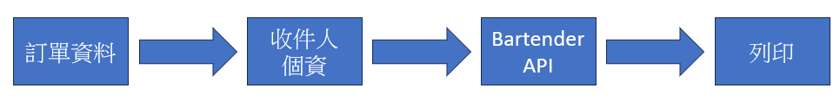

**Before**



1. 修改系統範圍

PROD： 192.168.1.137\hjdata\hjwms

192.168.1.52\EDL_Gateway

UAT：HjData_TEST\hjdata_test\hjwms

192.168.1.121\EDL_GatewayTest

1. 新增列印判斷邏輯

High Jump SP ：_SP_HJ_WBL_CSO_ESL_EC

WMS SP ：_SP_WMS_WBL_CSO_ESL_EC

EC API SP(GW)：SP_GetECinfor_ESLITE

UT

|  |  |
| --- | --- |
| 標籤 | 資料範例 |
|  |  |
| StoredProcedure | ConfigWorkBook |
|  |  |

## Test Cases

SIT

1.       202309117014201

|  |  |  |  |  |  |  |
| --- | --- | --- | --- | --- | --- | --- |
| **項次** | **階段** | **測試情境** | **預計結果** | **負責人** | **結果** | **備註** |
| 1 | SIT | 訂單配置成功 | 配置完成地址測試符合預期結果 | Jacky | Pass |  |
| 2 | SIT | 訂單轉撿貨成功 | 揀貨完成 | Jacky | Pass |  |
| 3 | SIT | 訂單驗放，CALL bartender列印面單 | 驗放完成並自動列印標籤與箱明細 | Jacky | Pass |  |
| 4 | SIT | 面單成功列印，欄位資料/隱碼正確 | 標籤資訊完整，箱明細收件人隱碼 | Jacky | Pass |  |
| 5 | SIT | 訂單發運成功 | 發運成功 | Ken | Pass |  |
| 6 | SIT | 上傳訂單至IM FTP | 產出檔案至FTP | Raines | Pass |  |

測試結果相關資料:

UAT

|  |  |  |  |  |  |  |
| --- | --- | --- | --- | --- | --- | --- |
| **項次** | **階段** | **測試情境** | **預計結果** | **負責人** | **結果** | **備註** |
| 1 |  |  |  |  |  |  |
| 2 |  |  |  |  |  |  |
| 3 |  |  |  |  |  |  |

## Business Case

針對本站進行導入EC API 取得收件人個資並由Bartender列印出貨標籤。

## Boundaries and Constraints

其餘路線不在此範圍內

# Part 3 – Contacts (as appropriate)

|  |  |  |  |
| --- | --- | --- | --- |
| Role | Name | Email | Phone |
| Developer |  |  |  |
| Requester |  |  |  |
|  |  |  |  |
|  |  |  |  |